EM314 –ASSIGNMENT 03

**LIYANAGE D.P**

**E/15/202**

**SEMESTER 4**

**QUESTION 01**

|  |  |  |  |  |
| --- | --- | --- | --- | --- |
| $$i$$ | 0 | 1 | 2 | 3 |
| $$x$$ | 1 | 2 | 3 | 4 |
| $$y$$ | $$ln1=0$$ | $$ln2=0.69315$$ | $$ln3=1.09861$$ | $$ln4=1.38629$$ |

$$l_{0}\left(x\right)=\left(\frac{x-x_{1}}{x_{0}-x_{1}}\right)\left(\frac{x-x_{2}}{x_{0}-x_{2}}\right)\left(\frac{x-x_{3}}{x_{0}-x_{3}}\right)$$

$$=\left(\frac{x-2}{1-2}\right)\left(\frac{x-3}{1-3}\right)\left(\frac{x-4}{1-4}\right)$$

$$=\frac{-1}{6}(x^{3}-9x^{2}+26x-24)$$

$$l_{1}\left(x\right)=\left(\frac{x-1}{2-1}\right)\left(\frac{x-3}{2-3}\right)\left(\frac{x-4}{2-4}\right)$$

$$=\frac{1}{2}(x^{3}-8x^{2}+19x-12)$$

$$l_{2}\left(x\right)=\left(\frac{x-1}{3-1}\right)\left(\frac{x-2}{3-2}\right)\left(\frac{x-4}{3-4}\right)$$

$$=\frac{-1}{2}(x^{3}-7x^{2}+14x-8)$$

$$l_{3}\left(x\right)=\left(\frac{x-1}{4-1}\right)\left(\frac{x-2}{4-2}\right)\left(\frac{x-3}{4-3}\right)$$

$$=\frac{1}{6}(x^{3}-6x^{2}+11x-6)$$

$$p_{3}\left(x\right)=ln1\frac{-1}{6}\left(x^{3}-9x^{2}+26x-24\right)+ln2\frac{1}{2}\left(x^{3}-8x^{2}+19x-12\right)+ln3\frac{-1}{2}\left(x^{3}-7x^{2}+14x-8\right)+ln4\frac{1}{6}(x^{3}-6x^{2}+11x-6)$$

$$=ln2\frac{1}{2}\left(x^{3}-8x^{2}+19x-12\right)+ln3\frac{-1}{2}\left(x^{3}-7x^{2}+14x-8\right)+ln4\frac{1}{6}(x^{3}-6x^{2}+11x-6)$$

$$=x^{3}\left(\frac{0.69315}{2}-\frac{1.09861}{2}+\frac{1.38629}{6}\right)-x^{2}\left(40.69315-\frac{71.09861}{2}+1.38629\right)+x\left(\frac{190.69315}{2}-70.69315+\frac{111.38629}{6}\right)-60.69315+41.09861-1.38629=0.02832x^{3}-0.313755x^{2}+4.27441x-1.15075$$

**QUESTION 02**

When we interpolate the function $f\left(x\right)=1$, the interpolation polynomial in Lagrange form is

$$P\left(x\right)=\sum_{i=1}^{n}{f\left(x_{i}\right)l_{i}\left(x\right)=\sum_{i=1}^{n}{l_{i}(x)}}$$

Since $f\left(x\right)=1$ the perfectly interpolated polynomial will be $P\left(x\right)=1$

This is the zeroth-order polynomial

Since $P\left(x\right)=1$

$$P(x)=\sum_{i=1}^{n}{l_{i}(x)}=1$$

**QUESTION 03**

**(a)** function [] = LagrangeInterpolant(x,y)

i = 1;

q = 1;

syms a;

pa = 0;

while (i <= length(x))

j = 1;

while (j <= length(x))

if i ~= j

q = q*(a - x(j))/(x(i) - x(j));

end

j = j + 1;

end

pa = pa + q * y(i);

i = i + 1;

q = 1;

end

disp(simplify(pa));

ezplot(pa);

hold;

plot(x,y,'ro');

**(b)**

LagrangeInterpolant([0 1/2 1],[0 1/4 1])

a^2

Yes, we get the answer as expected which is $a^{2}$

$$l_{0}\left(x\right)=\left(\frac{x-1/2}{0-1/2}\right)\left(\frac{x-1}{0-1}\right)$$

$$=2x^{2}-3x+1$$

$$l_{1}\left(x\right)=\left(\frac{x-0}{1/2-0}\right)\left(\frac{x-1}{1/2-1}\right)$$

$$=-4x^{2}+4x$$

$$l_{1}\left(x\right)=\left(\frac{x-0}{1-0}\right)\left(\frac{x-1/2}{1-1/2}\right)$$

$$=2x^{2}-x$$

$$P\left(x\right)=0\left(2x^{2}-3x+1\right)+\frac{1}{4}\left(-4x^{2}+4x\right)+2x^{2}-x$$

$$P\left(x\right)=x^{2}$$

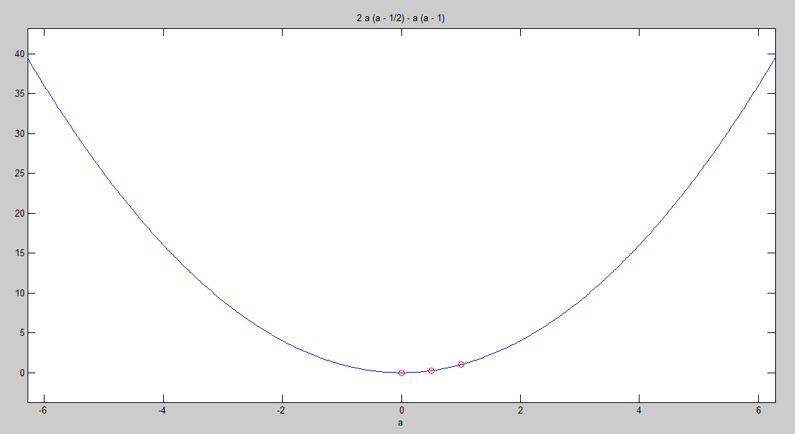

**QUESTION 04**

**(a)**

LagrangeInterpolant([0 -2 -4 -6 -8 -10],[29.1 29 28.7 28.2 20.7 19.1])

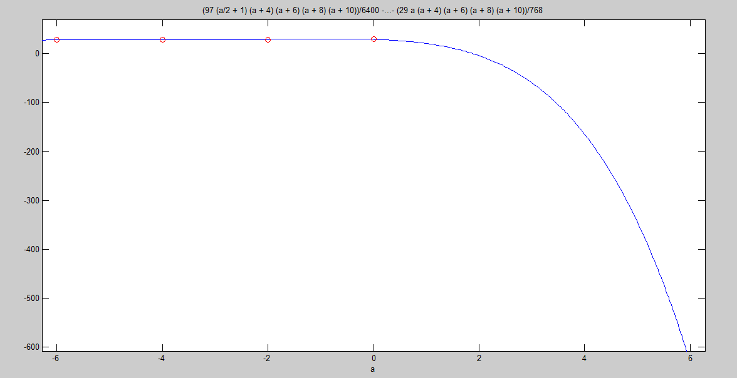

**(b)** By using the above code with this command a = sym(-7);

We can obtain the Temperature as $\frac{12949}{512}$ = 25.3 $℃$

But if we obtain this from the given table

$\frac{6-7}{6-8}=\frac{28.2-x}{28.2-20.7}$

$x=24.45$

Since the 2 answer are somewhat close, we can say that the answer we got from the Lagrange interpolate code is valid.

**(c)** function [] = LagrangeInterpolant(x,y)

i = 1;

q = 1;

syms a;

pa = 0;

while (i <= length(x))

j = 1;

while (j <= length(x))

if i ~= j

q = q*(a - x(j))/(x(i) - x(j));

end

j = j + 1;

end

pa = pa + q * y(i);

i = i + 1;

q = 1;

end

t = simplify(diff(pa));

eqn = t == 0;

sola = solve(eqn,a);

disp(sola);

As answer we get 4 data points,

-0.71219561215024224440289385707655

-3.090244960212241338508907742637

-4.9618529705648865831598105669069

-9.2885366457518751169472557579079

So maximum z value would be -9.2885366457518751169472557579079 m